Name _______________________________________ Date________ Hour ___________
Lab

Crime Scene Report:
At approximately 7:15 a.m. Thursday morning, Miss Duvall and Mrs. Washausen, the 6th grade science teachers, thought something was fishy when they walked into the building and noticed that the lab door was open and the lights were on. They walked into the classroom and discovered books on the floor; the class bulldog’s collar was on the counter but there was no dog!
The CSI team arrived and collected evidence. There were dirt footprints on the floor but they were not complete and were not usable evidence. However, several fingerprints were found on the doorknob and the counter top next to the dog. There was also a fingerprint found on the dog tag of the collar!

Alert: This just in...Our class bulldog is missing!! Your team of Crime Scene Investigators has been called in to help! The only evidence left behind was fingerprints!

- Problem: (state the problem as a question)

- Research: (What information would it be helpful to learn about to be able to answer this question?)

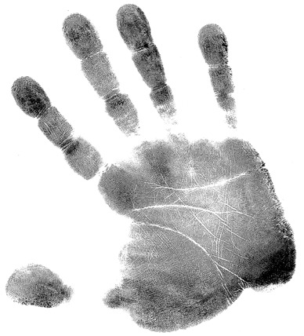3. Hypothesis: (Predict what you think it is you will find out)

4. Experiment
Materials:
Pencil
Index cards
Magnifying glass

Procedure:
- Be sure your finger print has been added to the fingerprint database!
- Analyze the fingerprints found at the crime scene!
- Compare the prints to the available fingerprint database (class fingerprints!) and collect data!

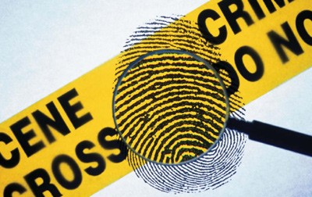

Analyze the crime scene data
Analyze the fingerprints collected at the scene. (loops, whorls, and arches)
- Circle the part of the fingerprint that help you to identify it from the others.
- What characteristics helped you determine the fingerprints uniqueness?
__________________________________________________________________________________________________________________________________________________________________________
- 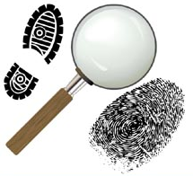Use your research and classify each fingerprint.
#1. ___________________________ #2. _______________________________
#3. ___________________________ #4. _______________________________
#5. ___________________________
Comparing to Database
Database comparison continued if needed! # the prints in order across the page!
Print # | Print Type | Print # | Print Type | Print # | Print Type
1 |  | 2 |  | 3
4 |  | 5 |  | 6
7 |  | 8 |  | 9
10 |  | 11 |  | 12
13 |  | 14 |  | 15
16 |  | 17 |  | 18
19 |  | 20 |  | 21
22 |  | 23 |  | 24
25 |  | 26 |  | 27
5. Analyze Data
Use a bar graph to show how common each type of print they are.

- What is the most common type of print in the class? _____________________________

- How will you narrow down the fingerprints to figure out which print matches the one found on the collar? ____________________________________________________________________

6. Conclusion (Referring to your hypothesis)

What would change the outcome of this experiment? (Hint: think back to all the fingerprints you saw, what would affect the results of the fingerprint identification? BE SPECIFIC!) List and explain 3 things!)

If you want to use fingerprints to solve crimes, you must have a way to describe, sort, and find prints that are similar to the one you find at a crime scene. The FBI has over 200 million prints on file; they can’t look through every single on to find a match.
Fingerprints are a great way to tell people apart because everyone's fingerprints are unique. This means that no two people in the world have the same fingerprints! Other ways of identifying people (hair color, height, weight, and eye color) may change as a person gets older, but fingerprints stay the same.

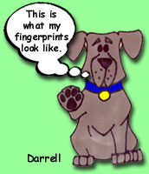There are over 250 million sets of fingerprint records on file. If all of the fingerprint cards on file were stacked on top of one another, they would equal one hundred and thirty three stacks, each the size of the Empire State Building! Finding space to keep all of these fingerprint cards is difficult!

This is one of the reasons that the FBI is now putting the cards in digital format so that the images can be stored on computers. All fingerprint cards at the FBI are eight-inch squares (a little smaller than a piece of notebook paper) and are thinner than a piece of cardboard. The FBI gets over 37,000 of these fingerprint cards each day, seven days a week! Thirty-two percent of these cards now come to the FBI as digital images.

